**Jenkins Bitbucket Integration**

Steps to integrate Bitbucket and Jenkins. And trigger the build when a code is modified/ committed/ changed in the Bitbucket repository. DevOps plays a very important role in application development. Every organization adopting DevOps in its project.

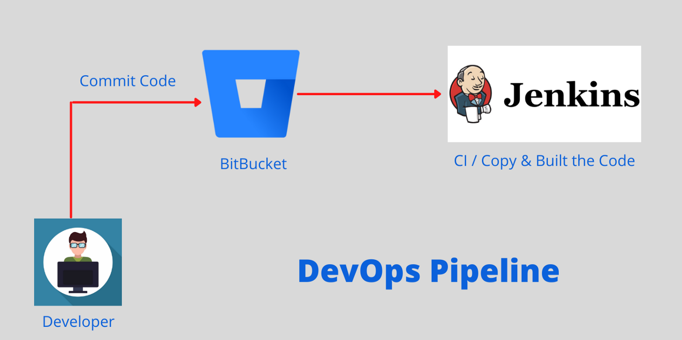

Step 1: Install the BitBucket Plugin in Jenkins

The first step involved in setting up BitBucket Webhook Jenkins Integration requires you to install the BitBucket Plugin in Jenkins. Follow the steps given below to install the plugin:

Login to your Jenkins account and open the Dashboard section.

Click on Manage Jenkins from the list of available options.

* + 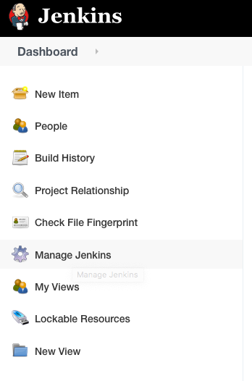
* Now click on **Manage Plugins** and navigate to the Search bar. Enter Bitbucket Plugin in the search bar and install the same.
  + 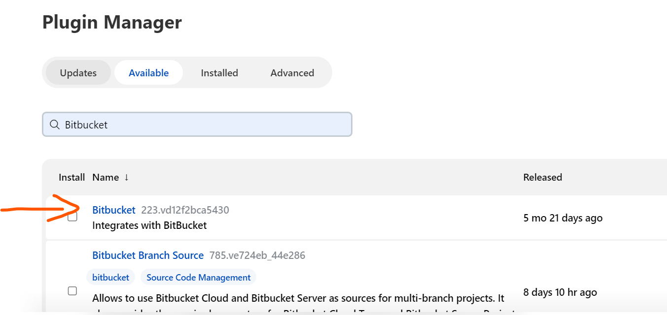
* **Step 2: Create a New Repository using BitBucket**
* Once you have installed the BitBucket Plugin in Jenkins, you will need a repository in BitBucket to link it with Jenkins. The second step in building BitBucket Webhook Jenkins Integration involves creating a new BitBucket repository. Follow the steps given below to do so:
* [Login](https://bitbucket.org/account/signin/) to your BitBucket account using the appropriate credentials.
* Once you have successfully logged in to your BitBucket account, click on the **Create** **Repository** button.
* [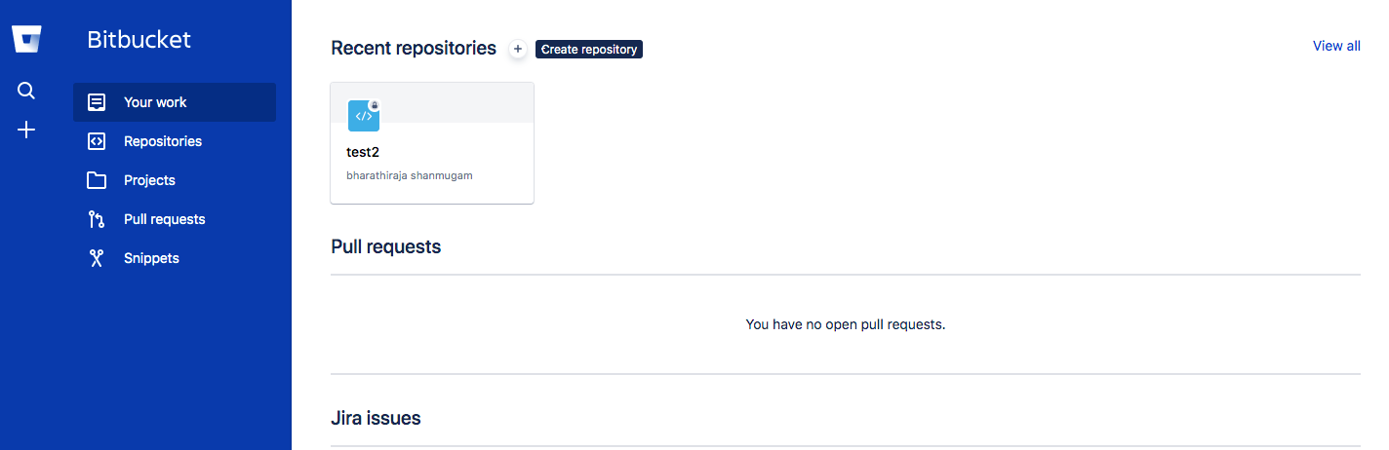](https://miro.medium.com/max/1500/1*PThQliDSTVsenxWXvq6PNQ.png)
* Add a name for your Project and Repository. You can also select the access level for your repository and make it **private or public** according to your needs. Once you are done filling all the required fields, click on **Create Repository** to save and create the repository.
* [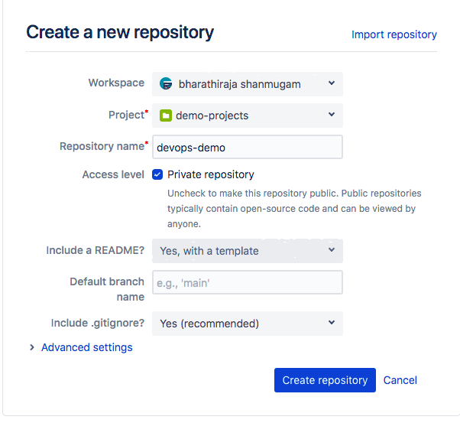](https://miro.medium.com/max/903/1*WAf4BayuG46TYUOBxmBI1Q.png)
* **Step 3: Create a New Job in Jenkins**
* Once you have the repository ready, go back to your Jenkins account and open the Dashboard.
* Select the option**New Item** from the list of options available to create a new Jenkins Job.
  + 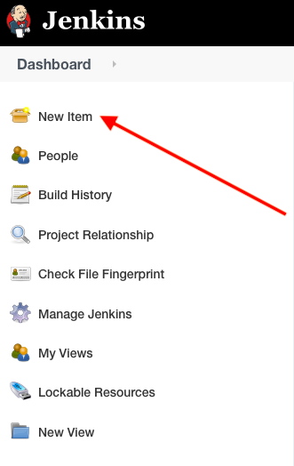
* Give a name to the Job that you are creating and select the option **Freestyle Project**. Once you are done filling the required fields, click on the **Ok** button to create a new Jenkins Job.
* [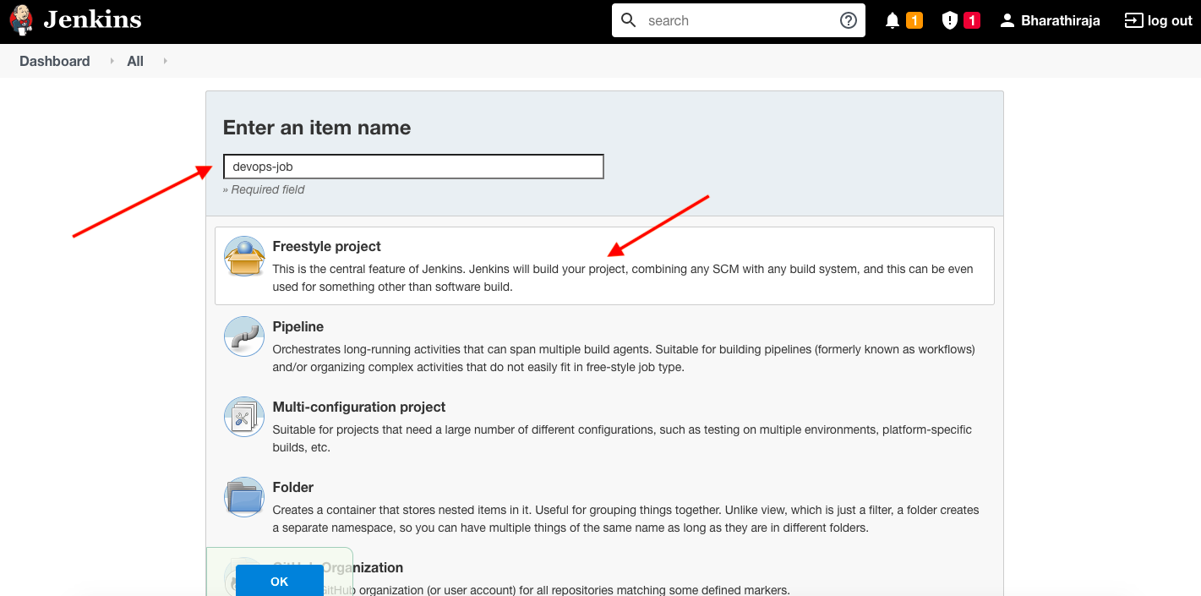](https://miro.medium.com/max/2132/1*Px0JZXlx_wI3oe4LY2jXiA.png)
* [Image Source](https://medium.com/ampersand-academy/integrate-bitbucket-jenkins-c6e51103d0fe)
* Now navigate to the **Source Code Management** section and click on the **Git** radio button.
* [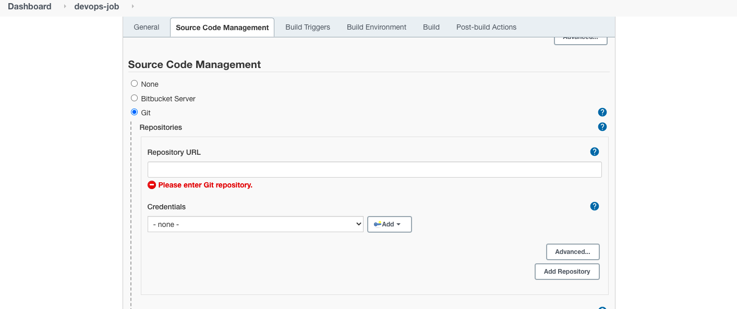](https://miro.medium.com/max/2120/1*YY7YfxcGKNrHQ0Yl7HZKSg.png)
* Add the link to your BitBucket repository that you created in the previous step to set up the BitBucket Webhook Jenkins Integration.
* Navigate to the **Build Triggers** section and mark the option “**Build when a change is pushed to BitBucket**”. Then click on the **Save** button to save all the changes
* **Step 4: Push Code to Jenkins using BitBucket Webhooks**
* The final step of the BitBucket Webhook Jenkins Integration is to configure it to push code-based changes to the Jenkins Server whenever new code is committed to the BitBucket Repository.
* Open BitBucket and navigate to the **Repository Setting**page.
* [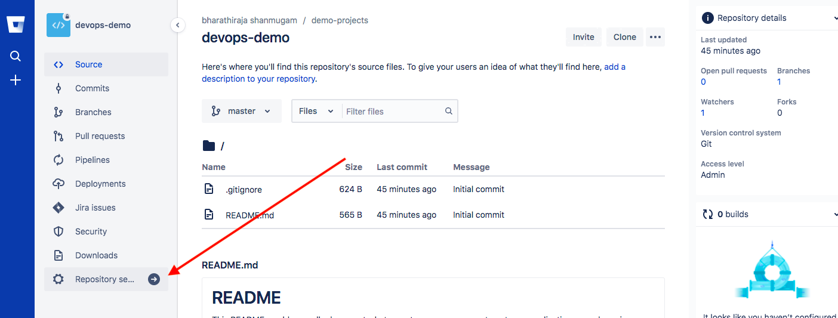](https://miro.medium.com/max/2106/1*NE1bYlqNc9jJdqfWb63iig.png)
* Select the option **Webhook** and click on the **Add Webhook** button.
* Give a name to the BitBucket Webhook and add the Jenkins URL in the URL field. You can also skip the certificate verification.
* Once you have filled the required fields, click on **Save**to save all changes.
* 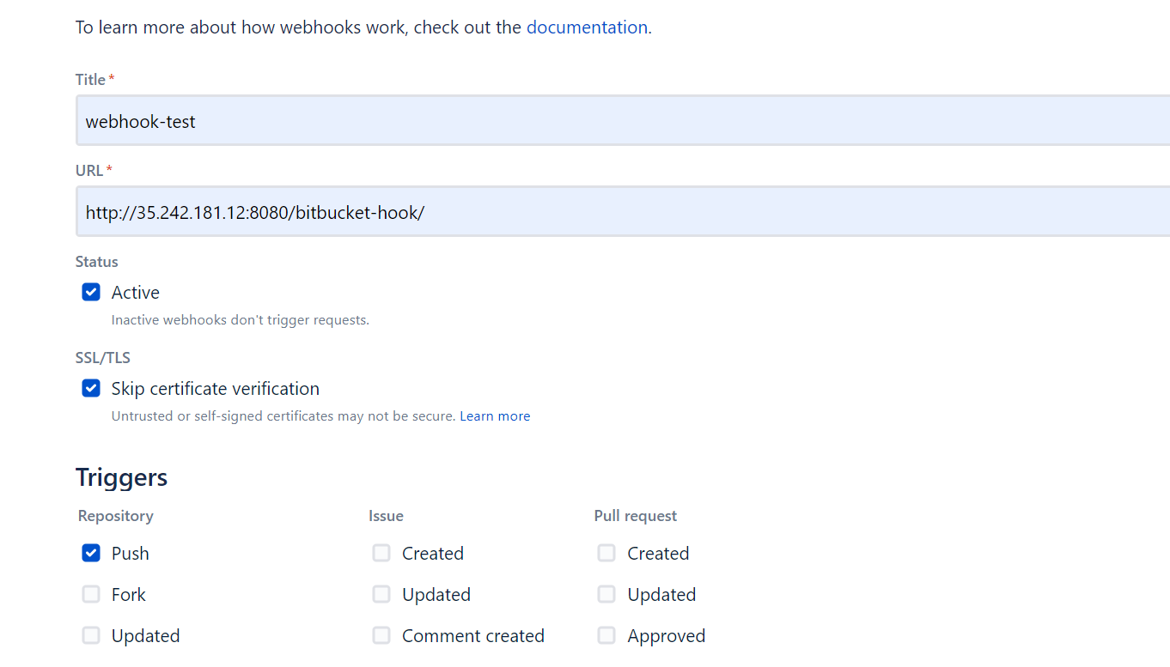
* 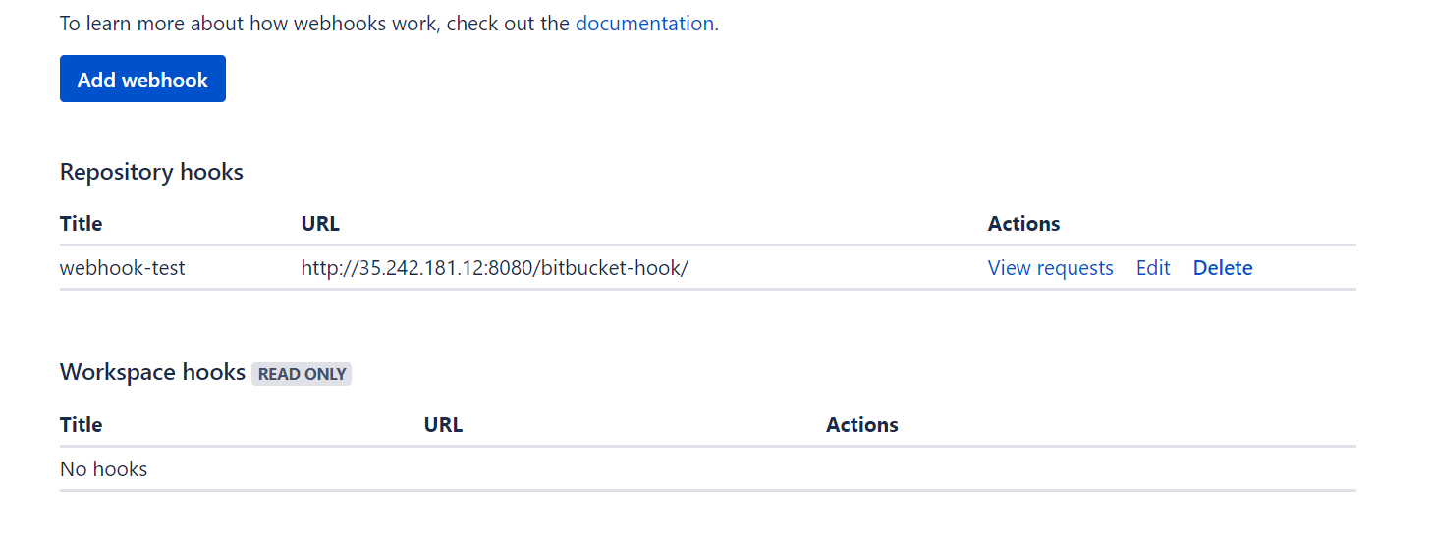
* Click on the view request to see if the webhook has been trigger successfully to Jenkins.

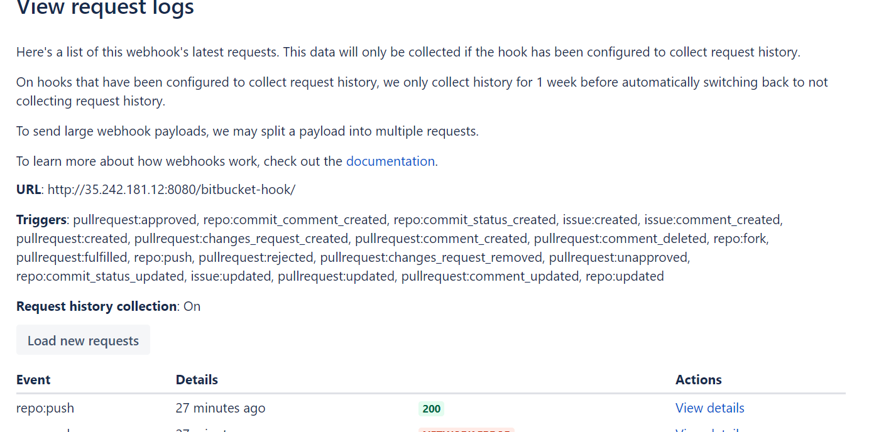

Sources: <https://plugins.jenkins.io/bitbucket/>